# Asheron’s Call 32bit Linux setup

**Tested on Kubuntu 24.04 and 25.10**

Asheron’s Call 32bit Linux setup 1

Step 1: Downloading the needed files 1

Step 2: setting proper Lutris settings 2

Adding Asheron’s Call to your Lutris 3

Step 3: Installing Asheron’s Call 4

3b continueing install 5

4 Starting the game 28

Intro

The text on the images might differ from what u are used to or wil see, the image’s where taken from a dutch os version. But the button locations and “error’s” should be on the same place. I did my best to translate the written text :) .

Ensure **Lutris** is installed useing Flatpak.

## Step 1: Downloading the needed files

This is not needed, the installer wil download the needed files, pre-downloading just might be a bit faster, definitly on the ac-updates.zip file.

Download all the needed files to make it a bit more easy

* Go to <https://emulator.ac/how-to-play/> and download the “Official Asheron’s Call installer” from Archive.org
* Scroll down to step 3 (skip step2 on the site) and download “End of Retail Client Files” labeld “ac-updates.zip” <https://mega.nz/file/Q98n0BiR#p5IugPS8ZkQ7uX2A_LdN3Un2_wMX4gZBHowgs1Qomng>

## Step 2: setting proper Lutris settings

Open Lutris and ensure your wine prefix is set to “wine-ge-8-26-x86_64 (default)”

Open Lutris, klik on the gear symbol next to wine

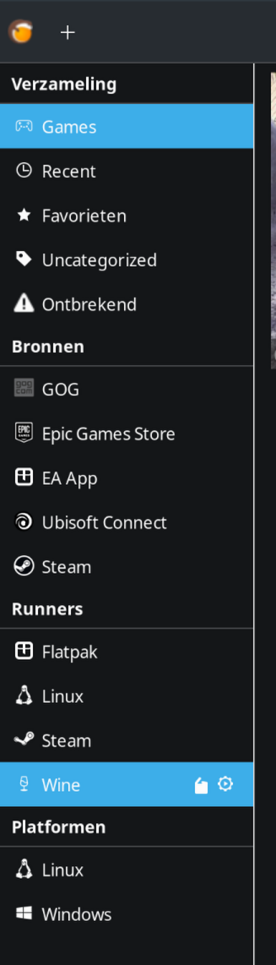

A new window opens where u can select the default wine-version , set this to “wine-ge-8-26-x86_64 (default)” for the asheron’s call setup.

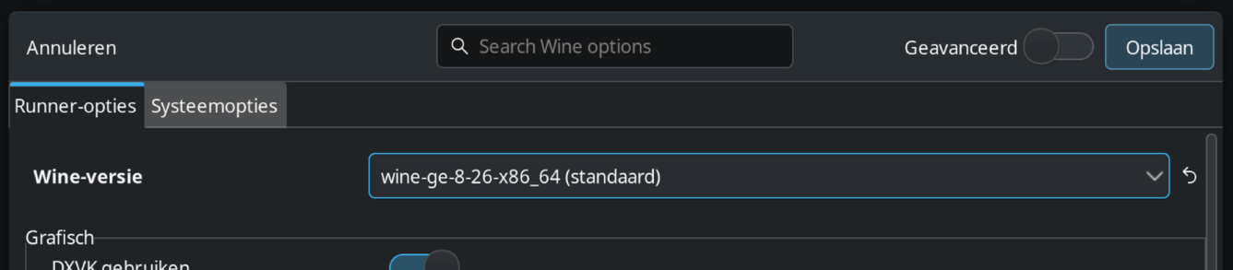

If it is one “wine-ge-8-26-x86_64 (default)” than klik on “save” in the top right corner.

### Adding Asheron’s Call to your Lutris

U can go to <https://lutris.net/games/asherons-call/> and klik on “Add to my library”

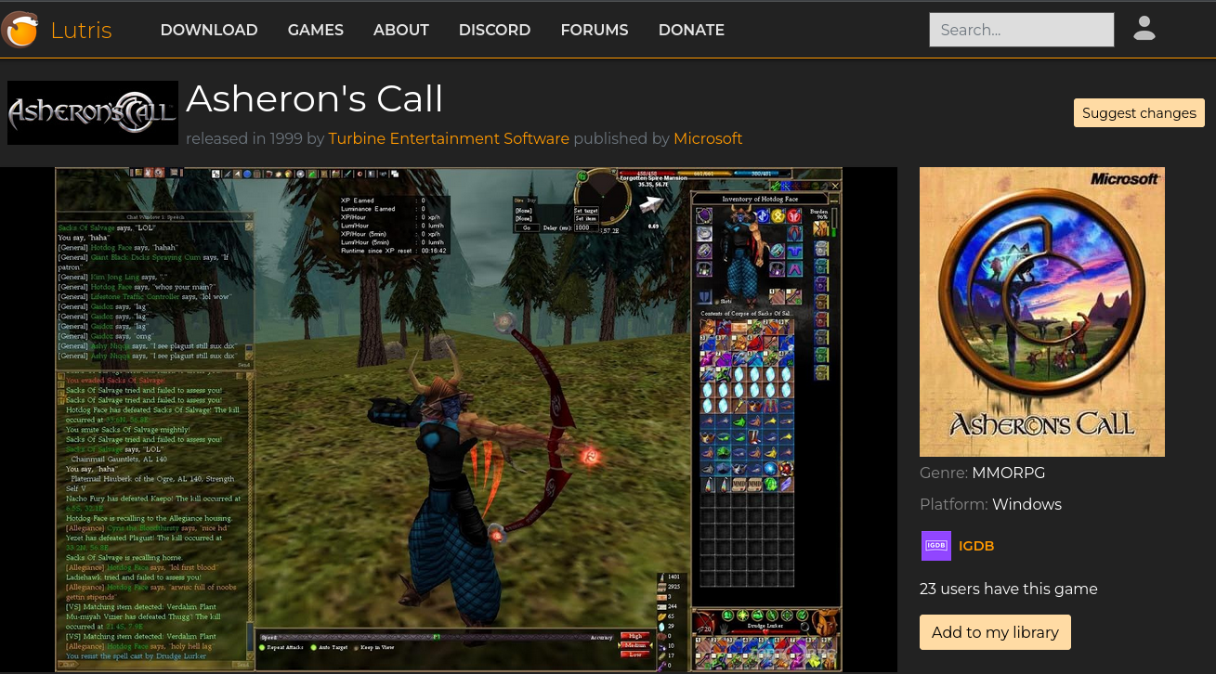

This wil give u a nice image in Lutris wich u can doubleklik to start the install

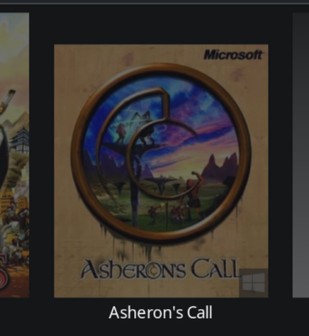

If u do this, skip to section “3b continueing install”

## Step 3: Installing Asheron’s Call

If u do not want to add Asherons call to your library than u need to download the yaml file first

U can find it at <https://github.com/Aircorian/Asherons-call> labeld “AC 32bit.yaml”

Add a new game to Lutris, hit the “+” symbol in the top left corner.



In the new window klik on “Install from a local install script”

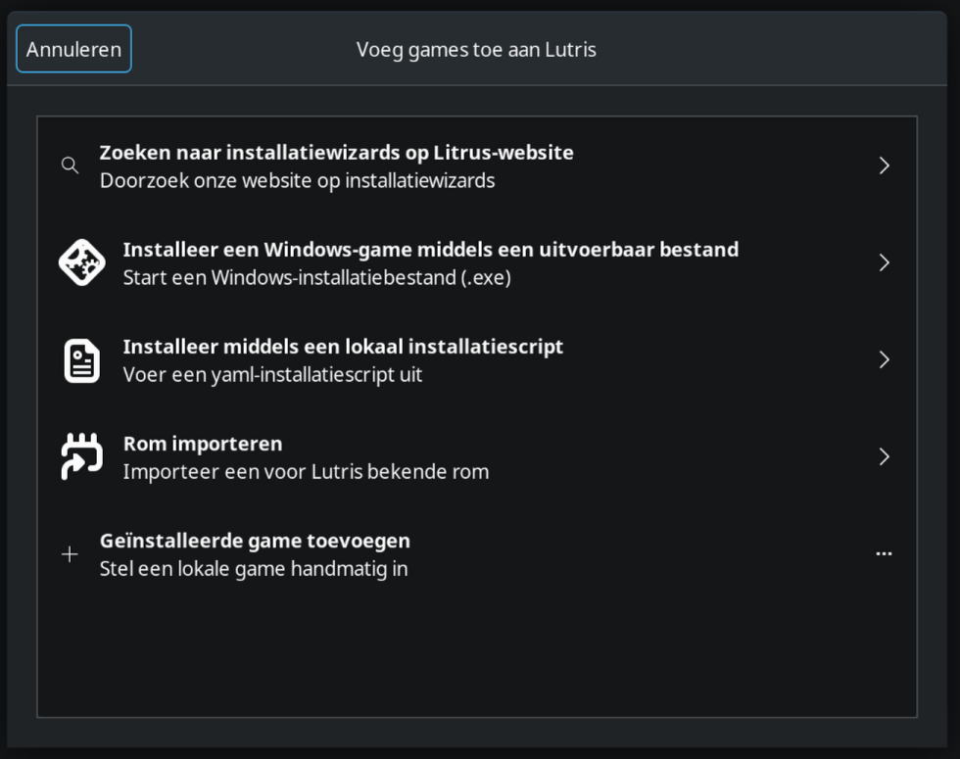

On the new screen, klik on the 3 dots

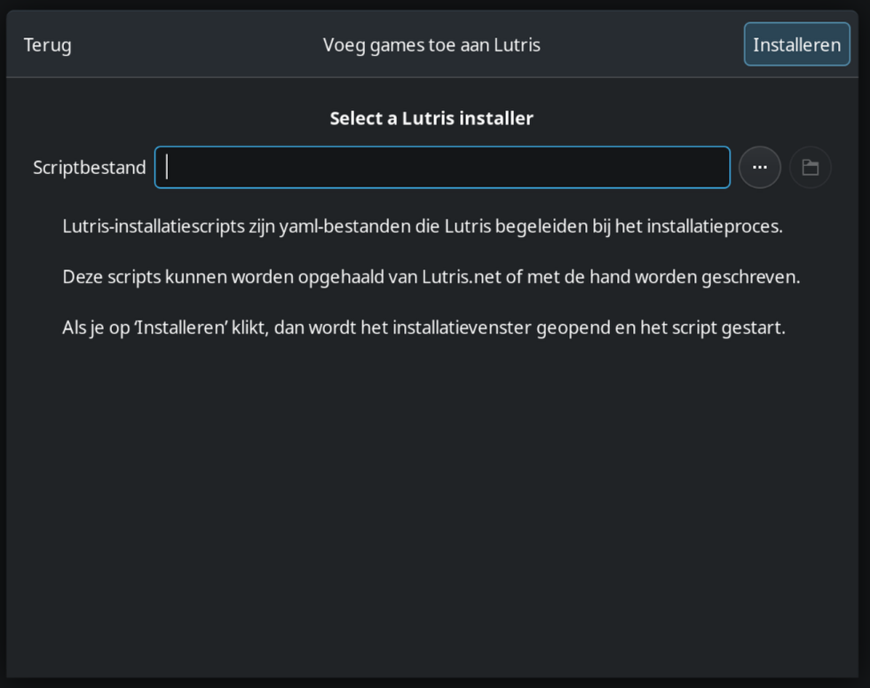

Browse to the folder where u downloaded the yaml file and select “AC 32bit.yaml” and klik on “ok” in the window, this wil return u to Lutris and put in the correct path in “Script file”

Now u can klik on “Install” on the top right corner.

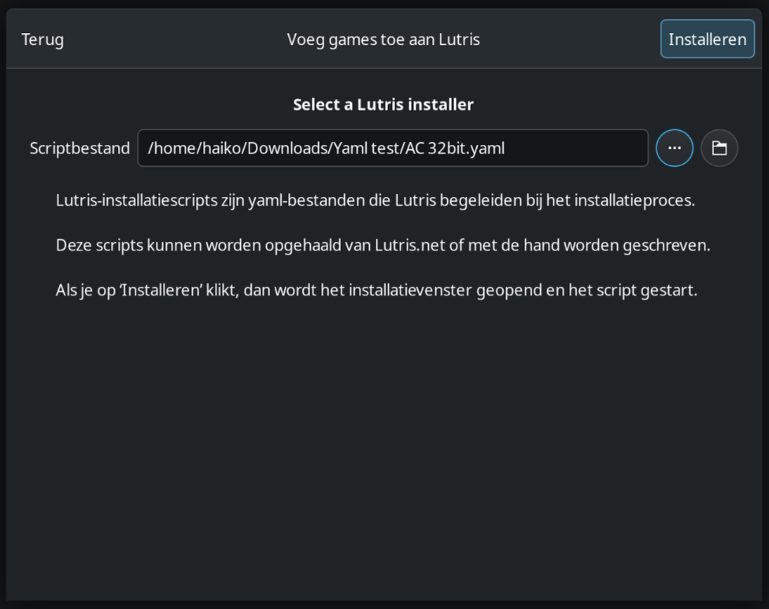

### 3b continueing install

Klik on “Install” again in the new window.

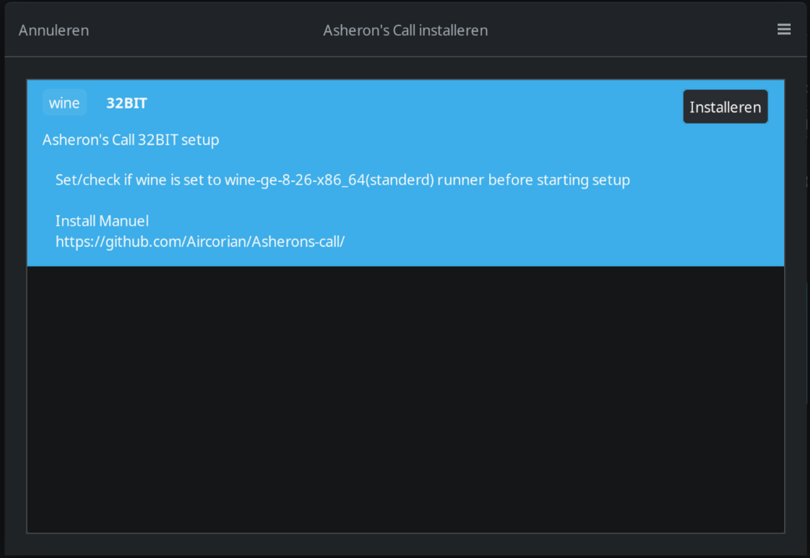

At the next window, set the prefix to where u want the game installed.

When its set to preferd prefix u desire (or the default one) klik on “Continue” in the top right

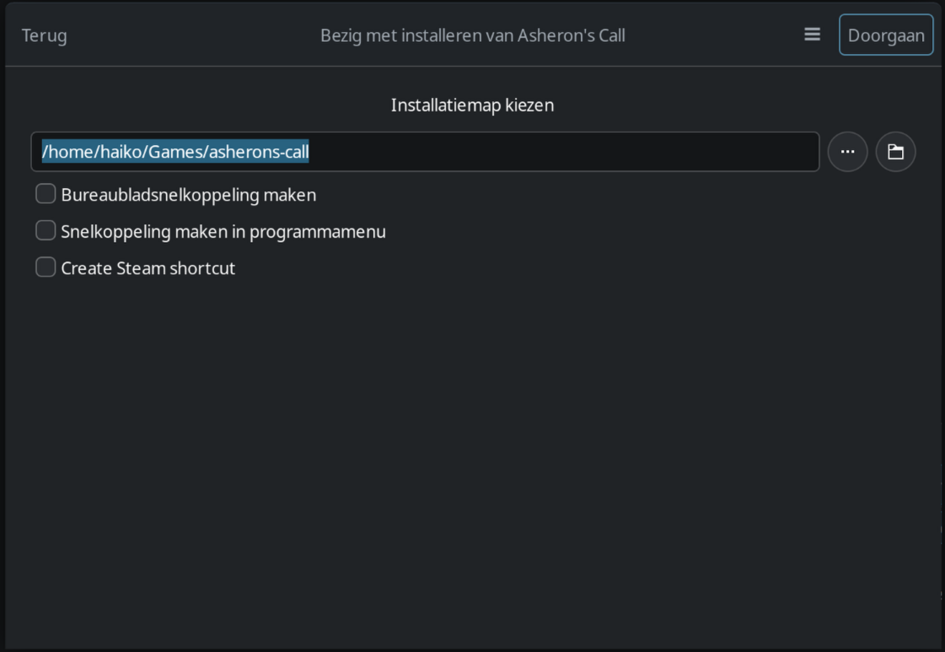

In this new window u can let the installer all the needed files itself and just klik on “Install” if u want to do some manual work (could be faster) check the next image.

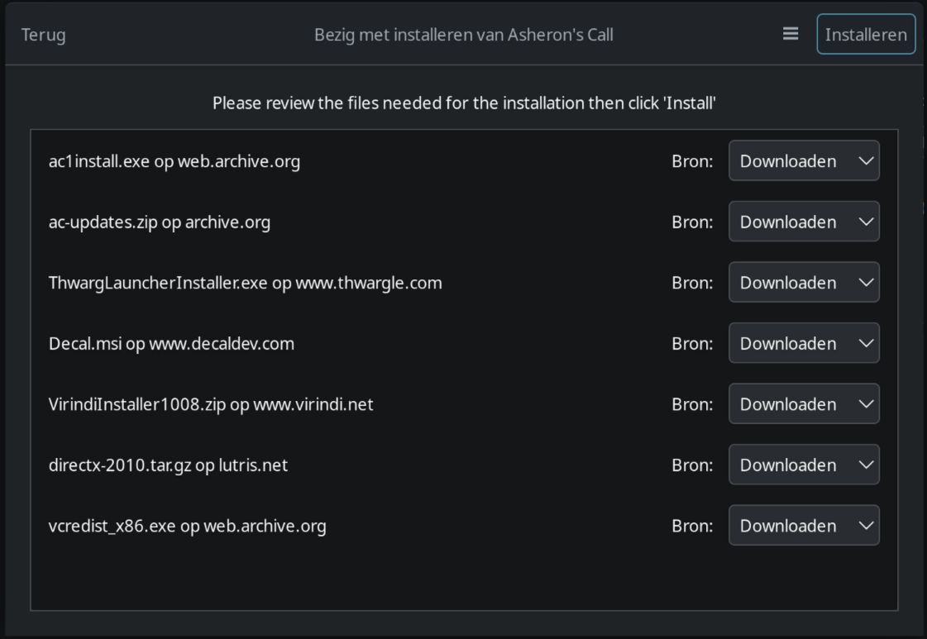

Settin the ac installer and update files manually.

Klik on the “Download” button to change it to “Choose File”

Select the ac installer and the update files, ensure that u put the installer with the correct requested installers, do not accidently swap the files (so do not accidently put the ac-updates.zip as the ac1install.exe location or otherwise)

Klik on the 3 dots right of the prefix box and browse to the file locations.

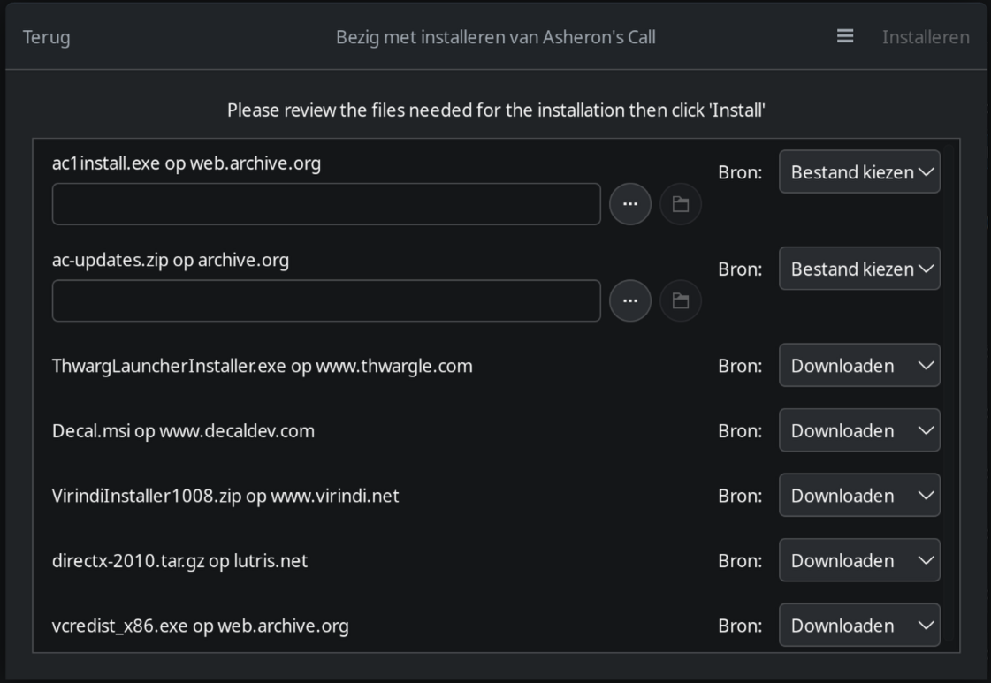

Now klik on the top right corner on “Install”

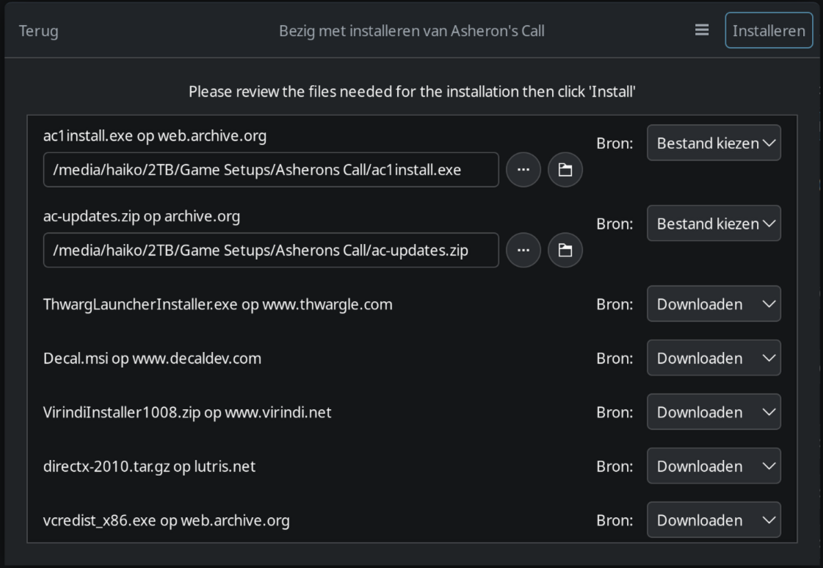

Let Lutris do its thing untill the Asheron’s Call installer opens up.

First klik on “Next”

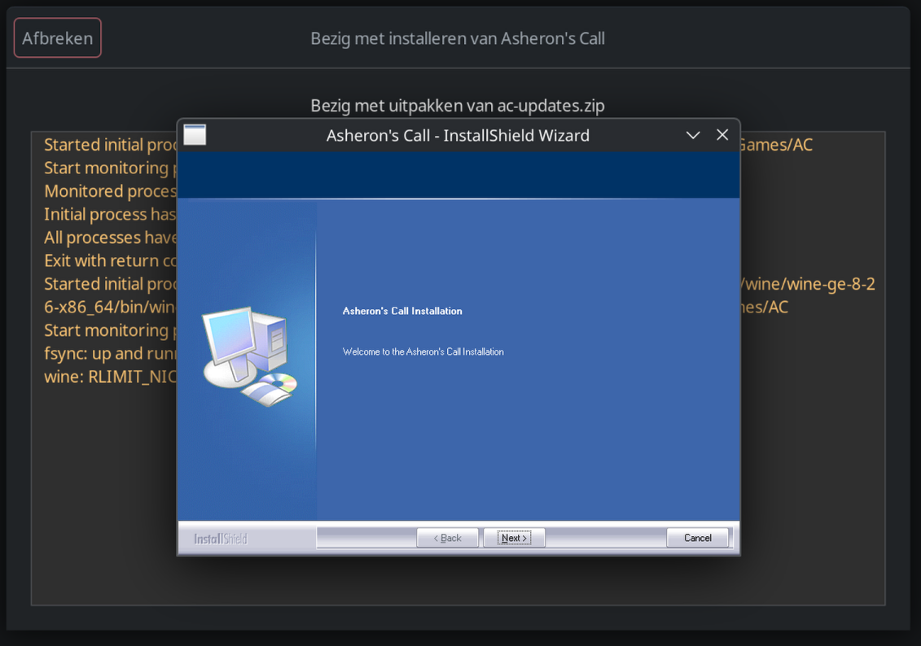

Than klik on Next again

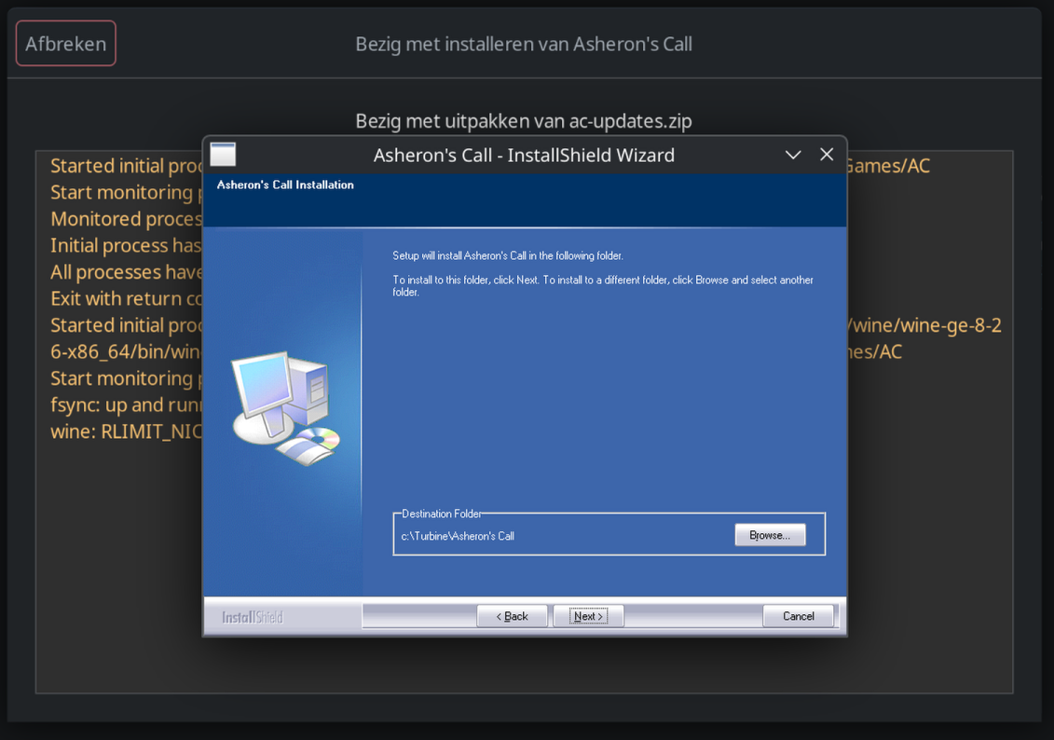

U get a message saying the directory was successfully made, klik on “OK”

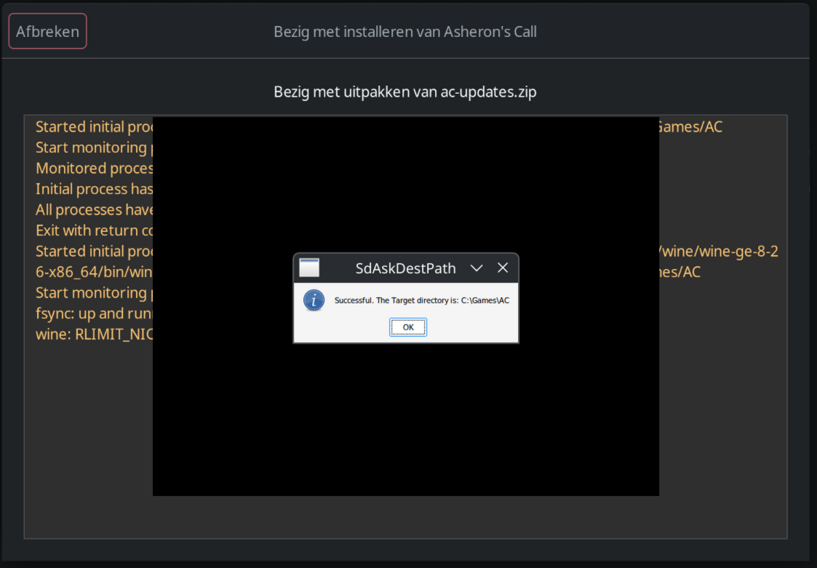

And after that u can klik on “Install”

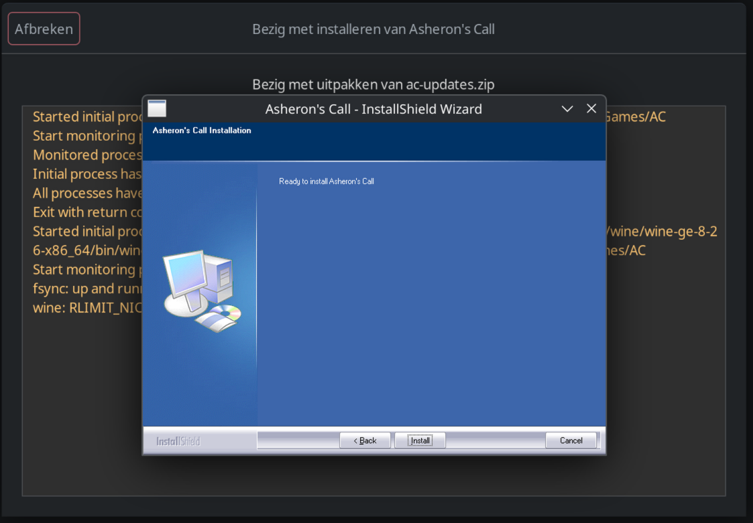

Let the setup finish and klik on “Finish”

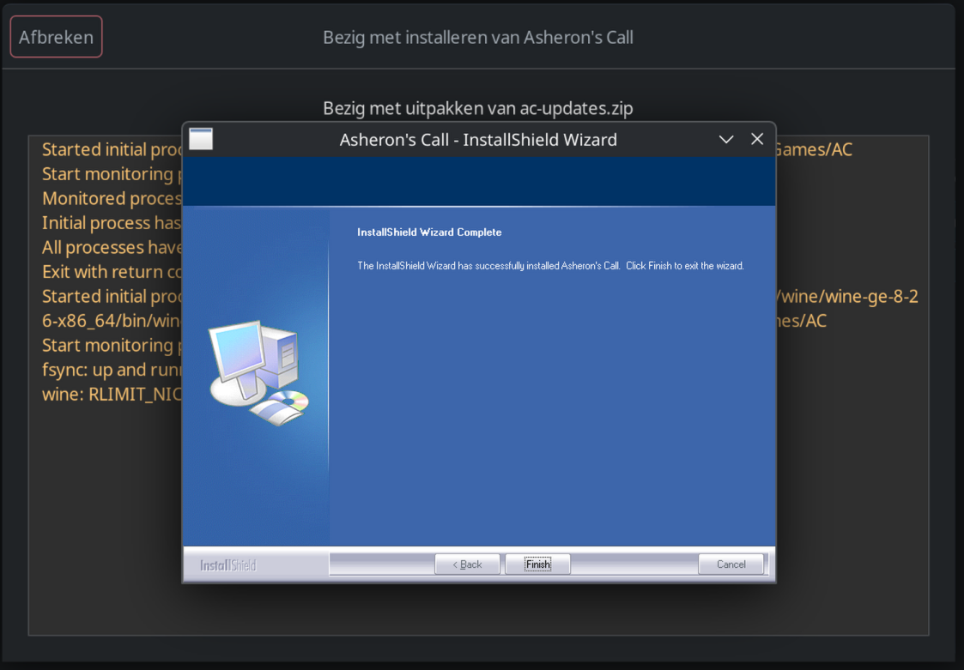

Than wait and let Lutris to unpack and place the .dat files in the right place, after that it wil auto start the decal setup.

klik on “Next”

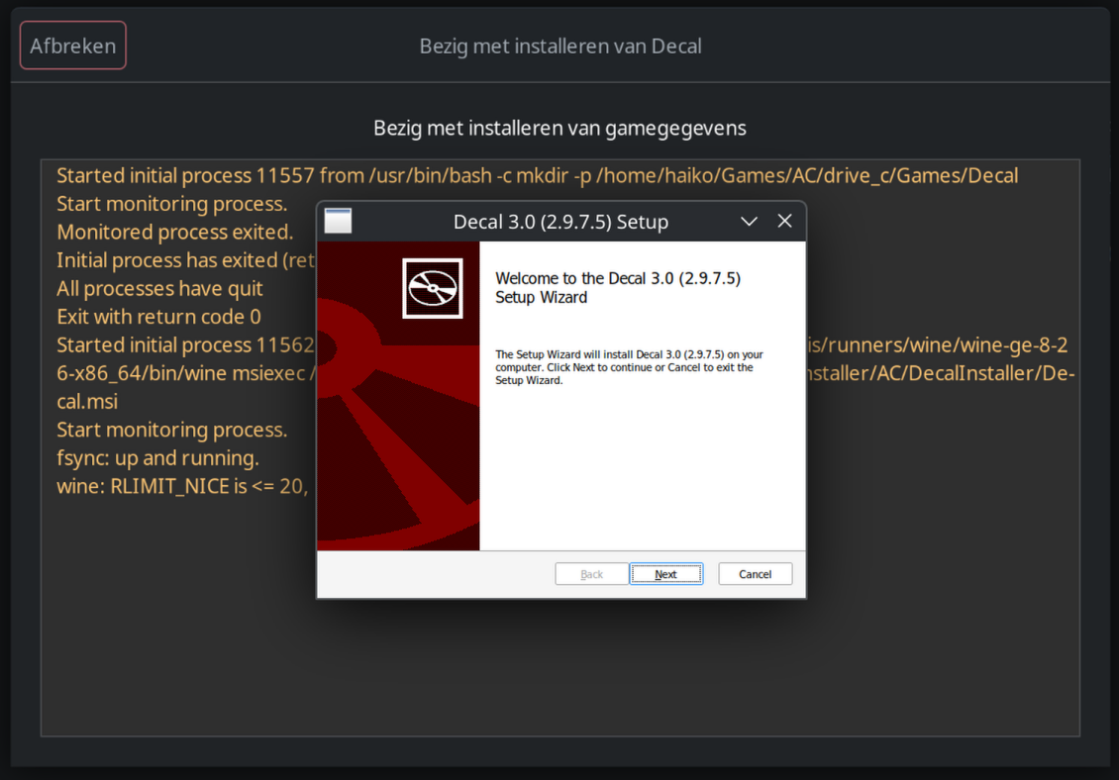

Mark “I accept the terms in the License Agreement” and klik on “Next”

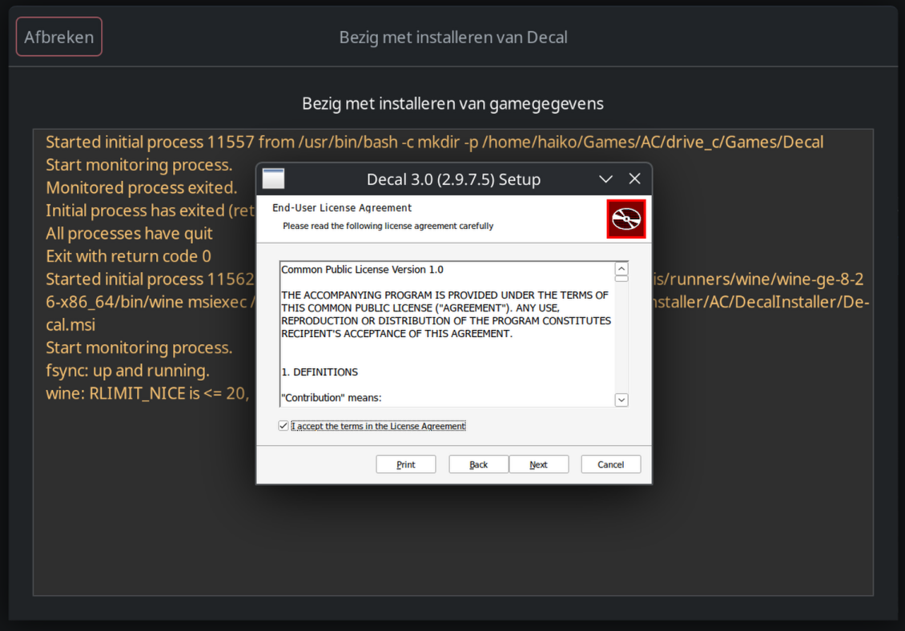

After that klik on “Compelete”

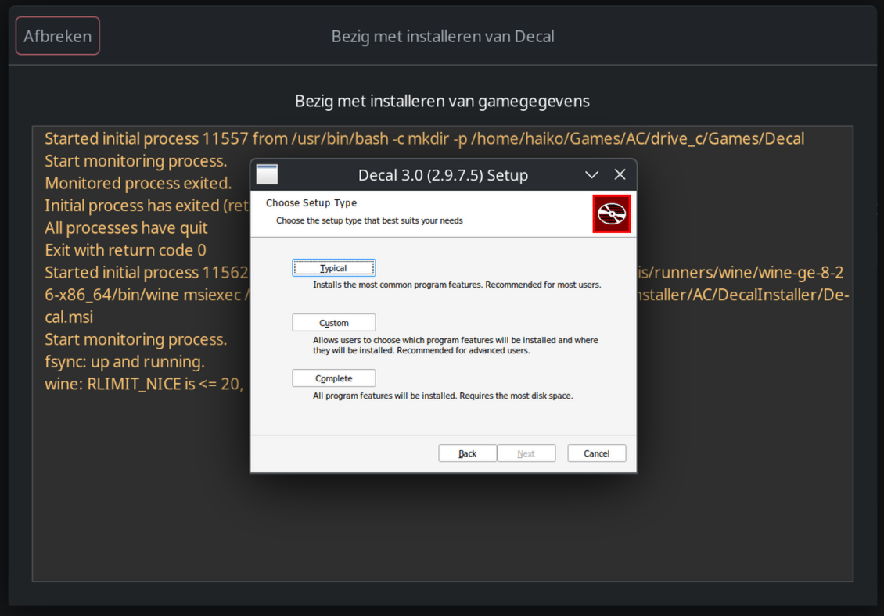

And now klik on “Install”

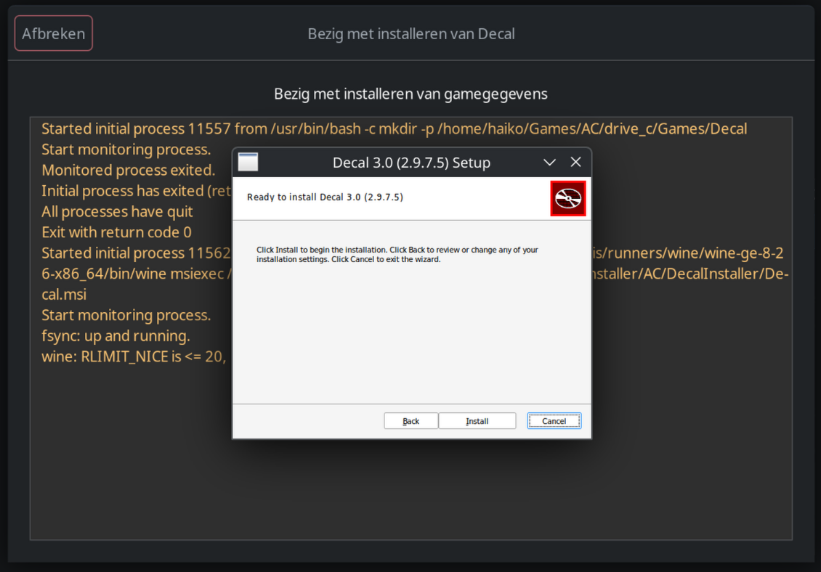

When the setup is completed it wil open another window to browse folders.

Klik on Finish first (not mandatory, but it closes the installer and u just decal wil be open after that wich is cleaner)

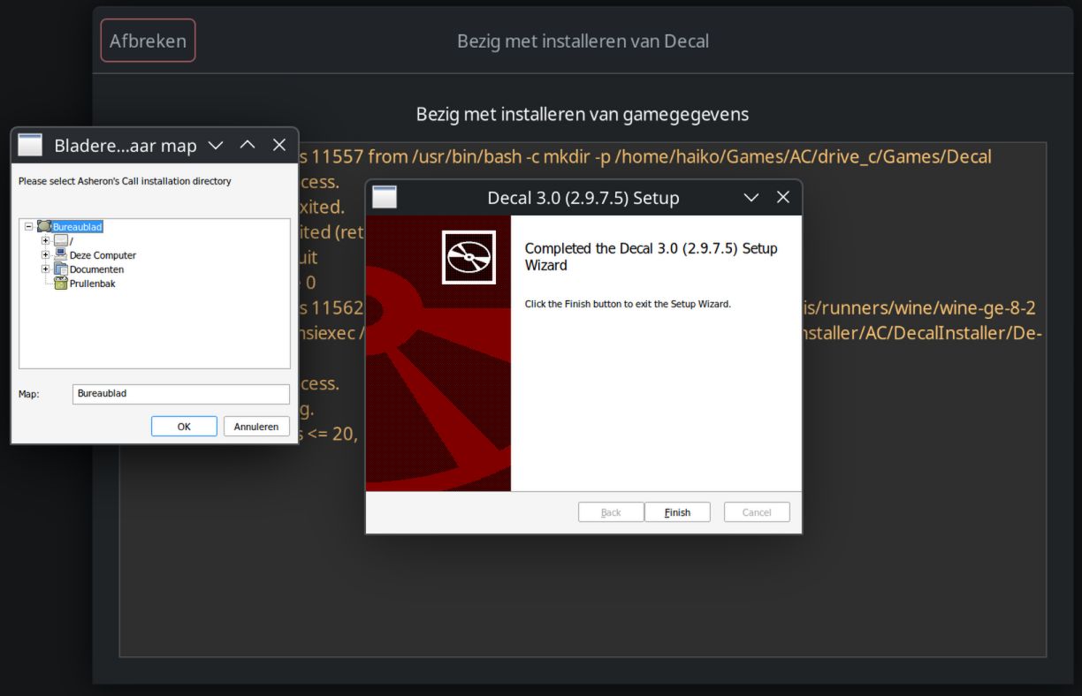

Browse to the Asheron’s Call install location, insure that the Folder is showing as Asheron’s Call bye klikking on the folder in the browser menu.

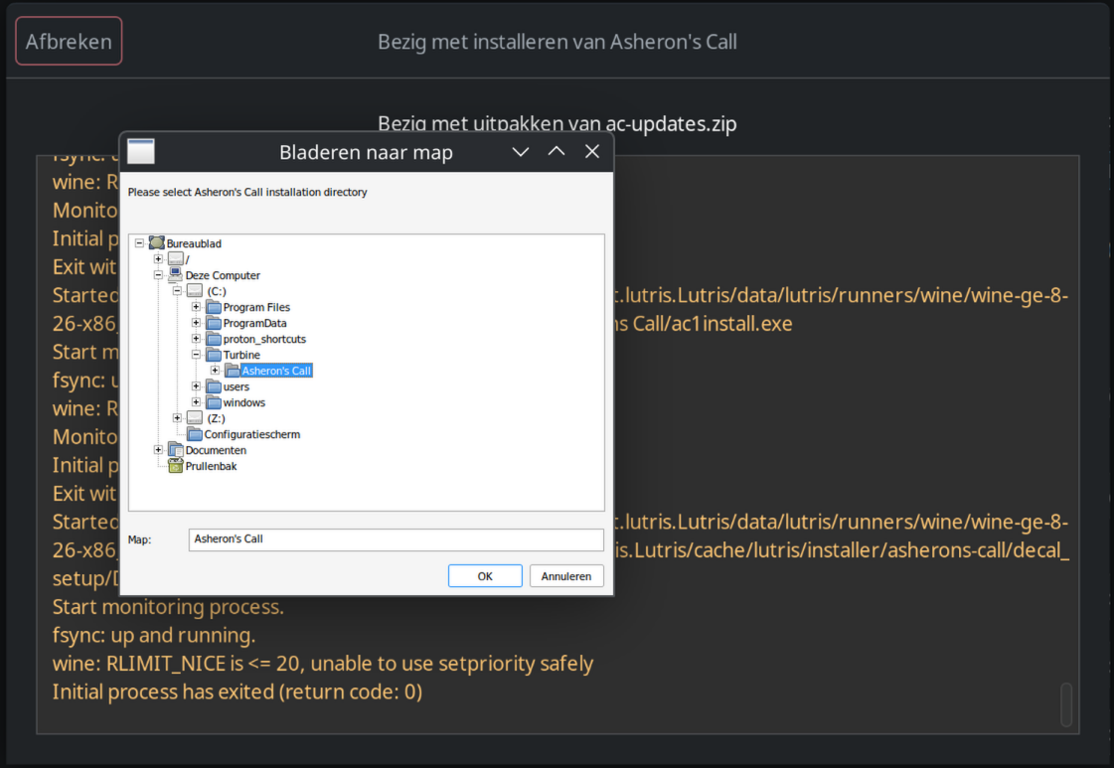

If the folder is set to Asheron’s Call than klik on “OK”

A error window with yellow triangel named “DenAgent” opens, klik on “OK”

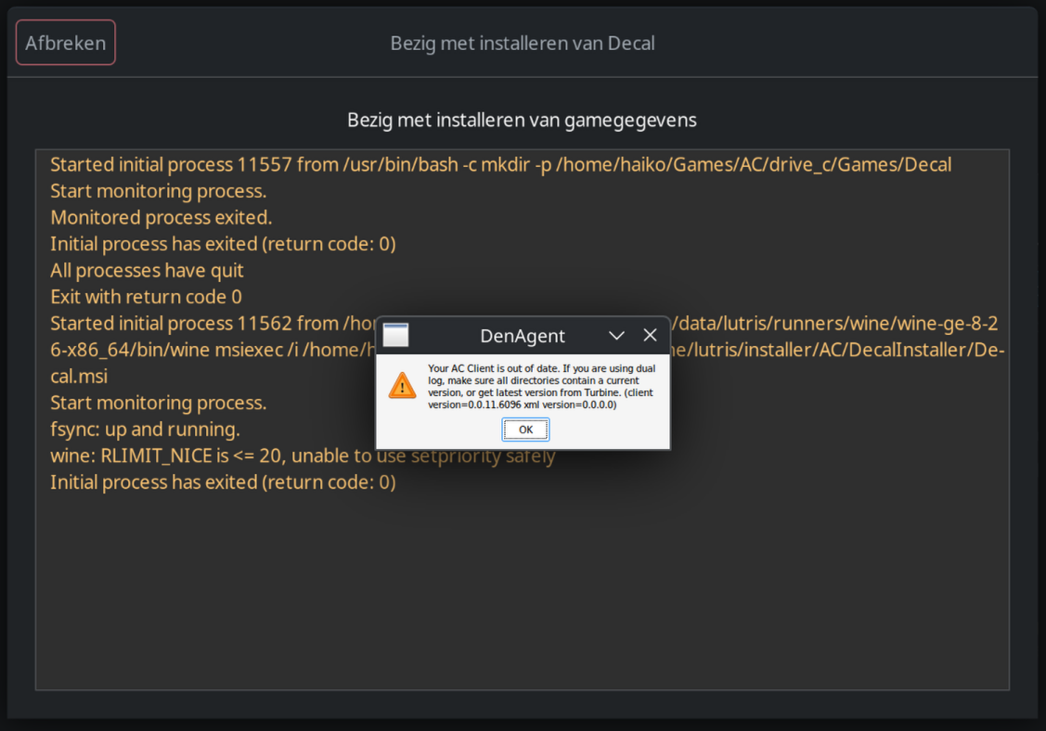

Decal wil now be running, u can open Decal itself bye dubbelklikking on its icon in the taskbar in order to update it



U wil get a error message saying it is missing XML files, klik on “OK” and Decal opens

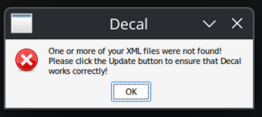

In decal klik on “Update” and let Decal update

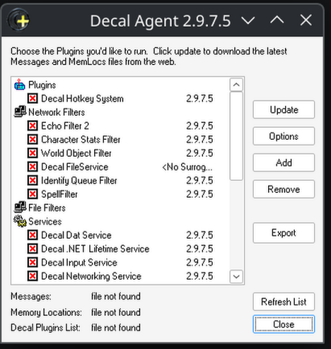

At the end u get a message saying “your Decal components have been updated” , klik on “OK”

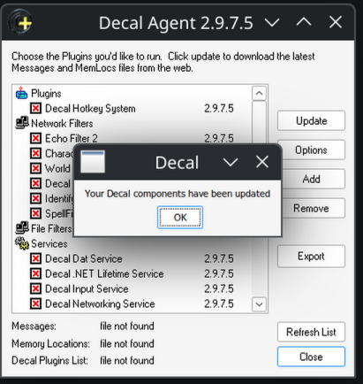

All plugins shoud have a black V marked, but 1 wil have a red X , this is normal, u can klik on “Close”

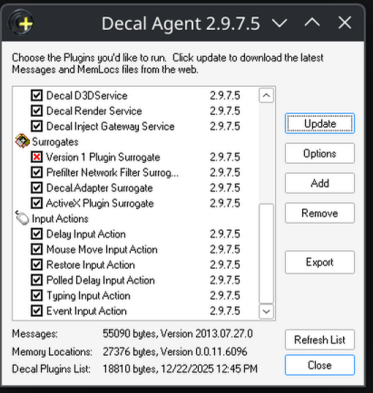

Check if everything is propperly listed with a black V , only “Version 1 Plugin Surrogate” should be a red X , than close Decal and hit “Exit” as before

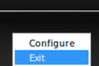

When u hit Exit, Lutris wil continue the setup and automatically start the Thwargle installer, klik on “Next”

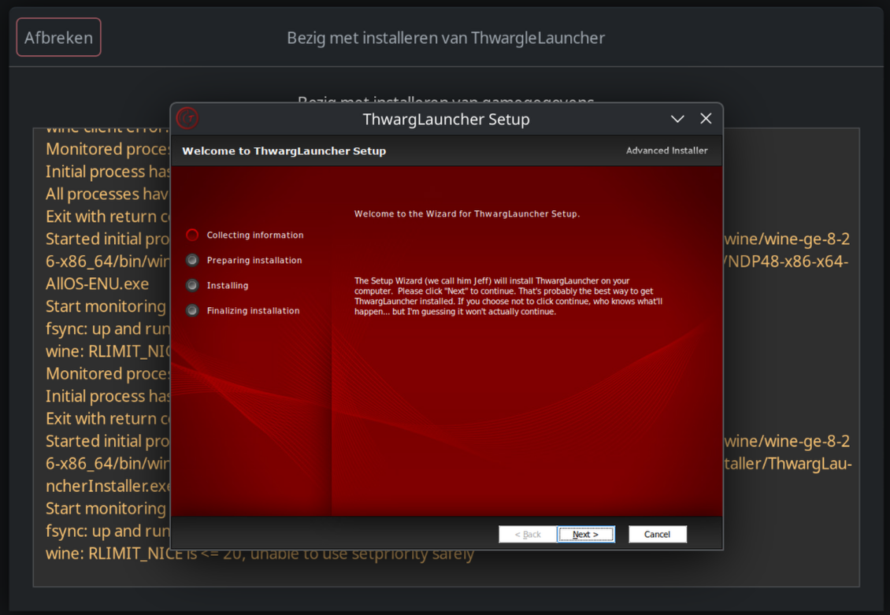

Than klik on “Next” again

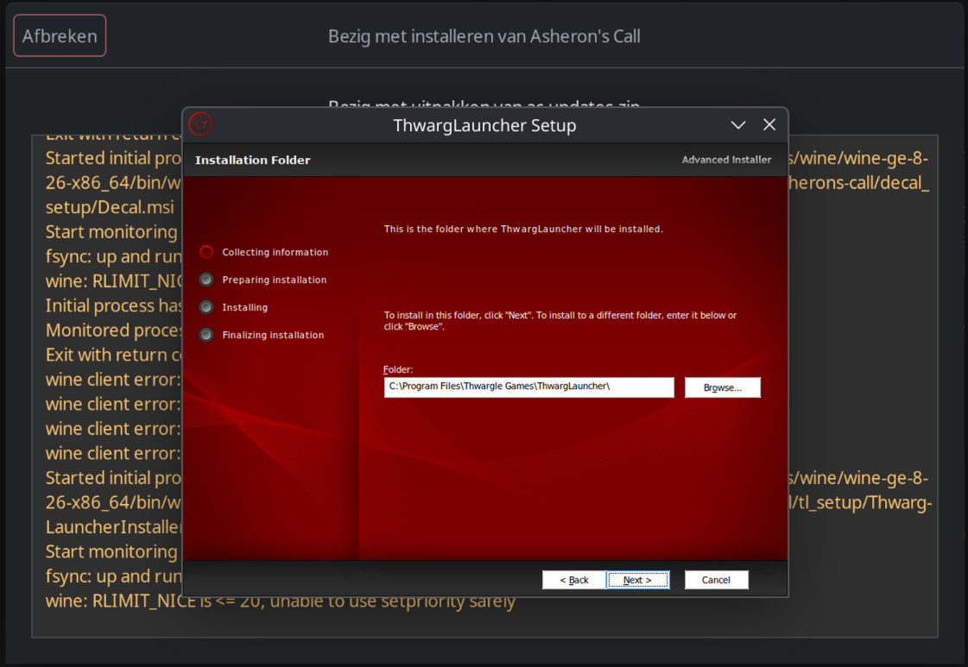

Now there is a visual bug, but u have to select the top section to accept the license agreement.

After that u can klik on “Next”

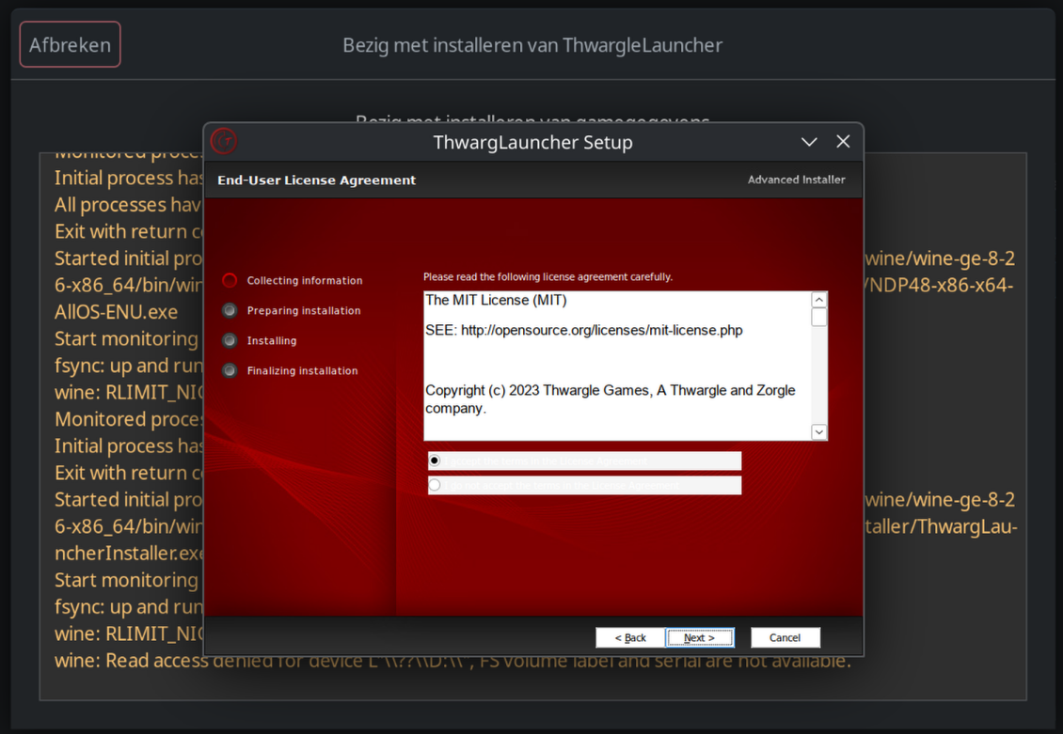

In the next window u than klik on “Install”

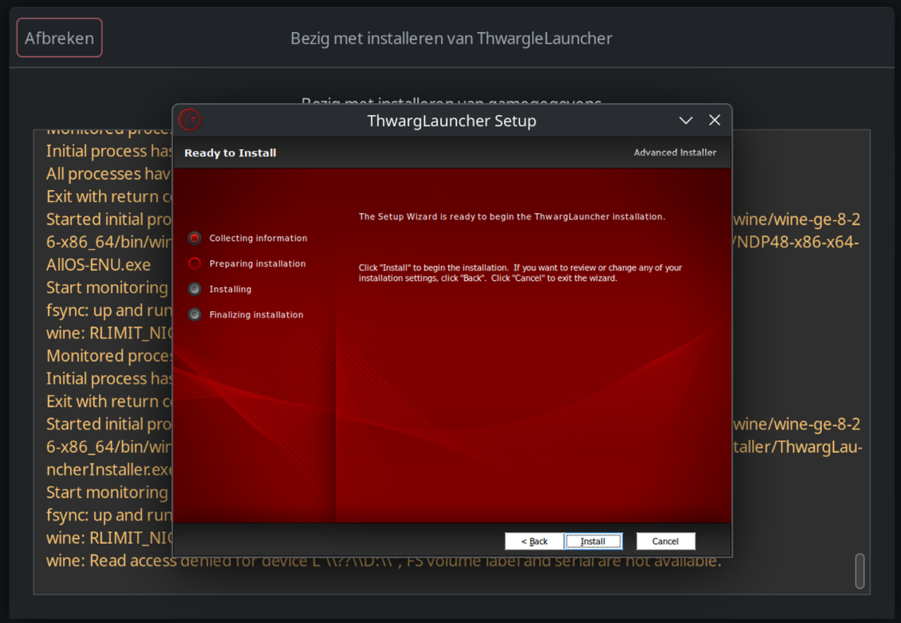

When the setup is complete do NOT check the blank box (graphic bug) , just klik on “Finish”

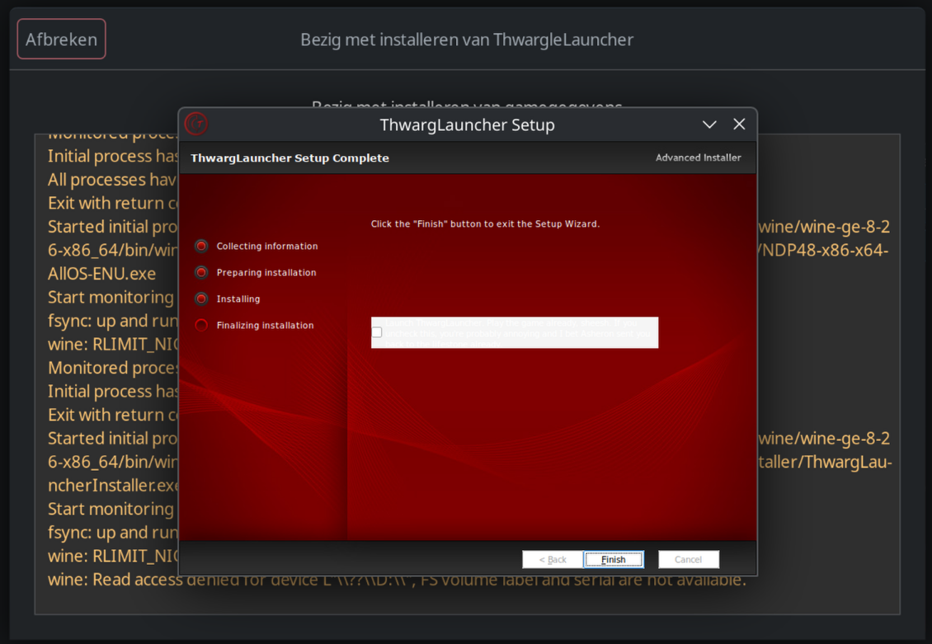

After klikking on finish Lutris wil continue and start virindi plugin installer, klik on “Install”

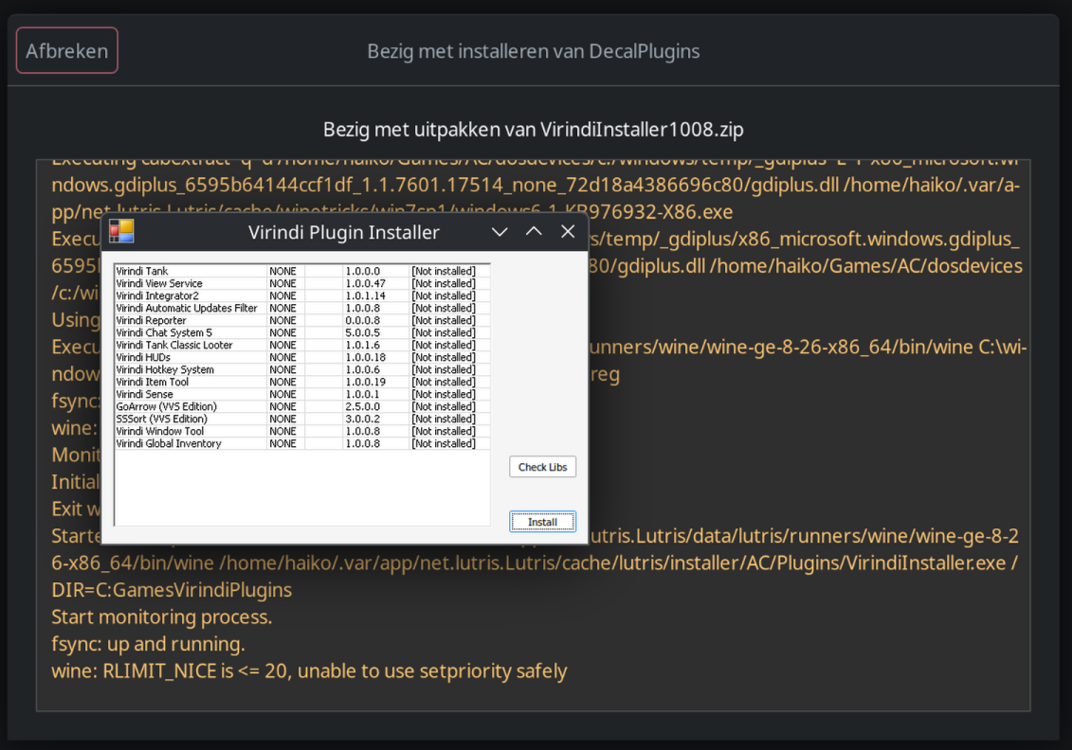

klik on “Okay”

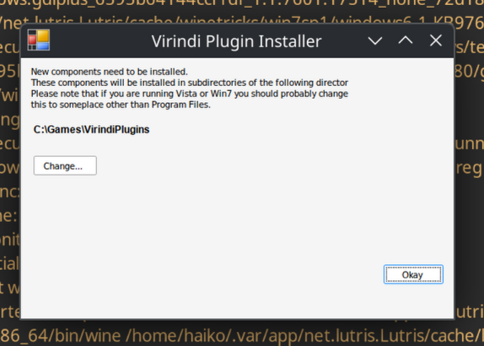

A batch file opens, let it run untill it stops at “Install complete. You may close this program.”

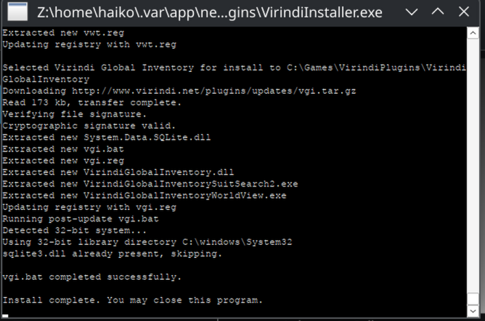

Just close the batch file bye klikking on the top right X



Lutris wil now complete the installation process and u wil see the “Installation completed!” message, just klik on “Close” in the top left corner.

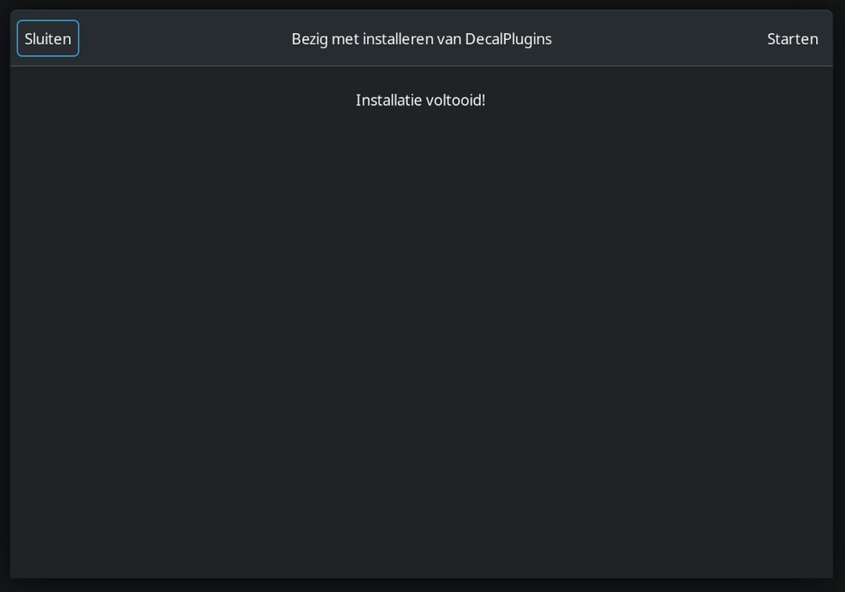

In Lutris rightklik on “Asheron’s Call” and klik on “Settings”

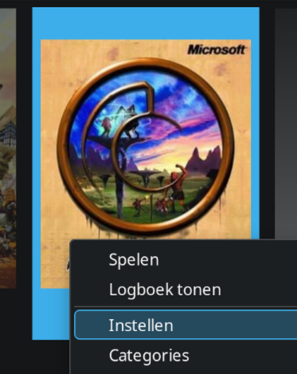

Go to the tab “Game-options” and set the profilearchitecture to “32-bit”

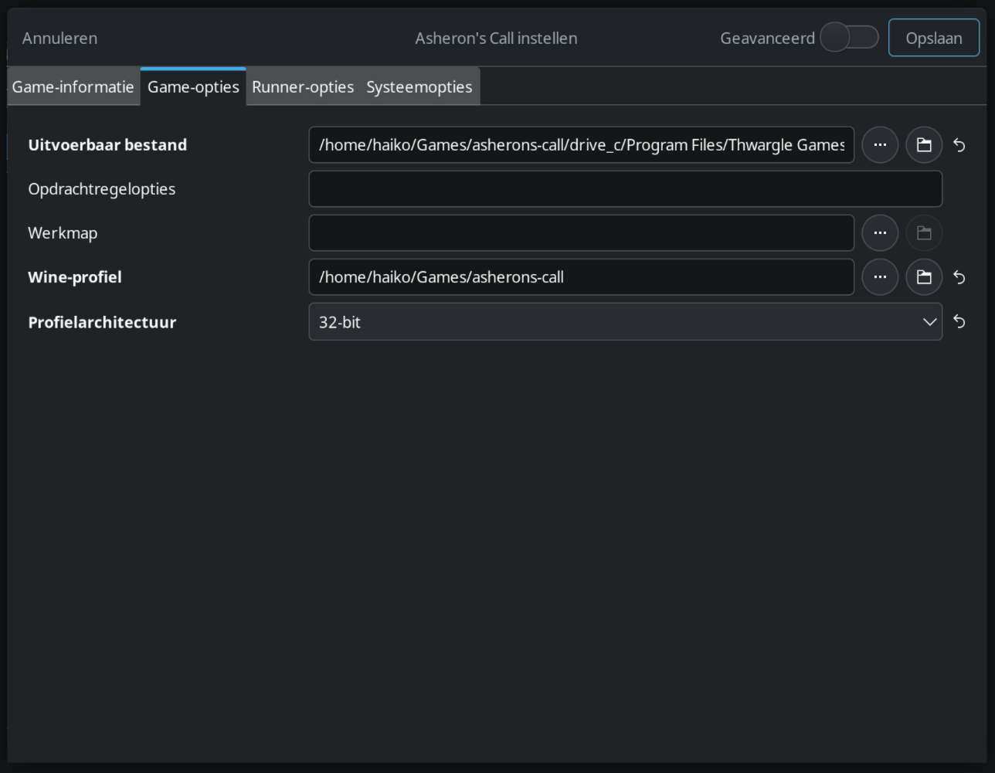

When it is set to “32-bit” klik on the top right on “Save”

In Lutris dubbelklik on “Asheron’s Call” to open the startup menu

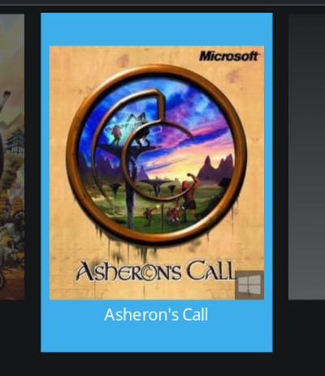

Select Decal and klik on “OK”

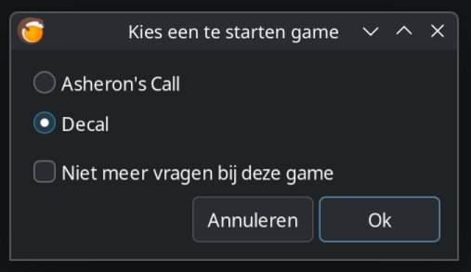

Now open Decal again and klik on “Add”

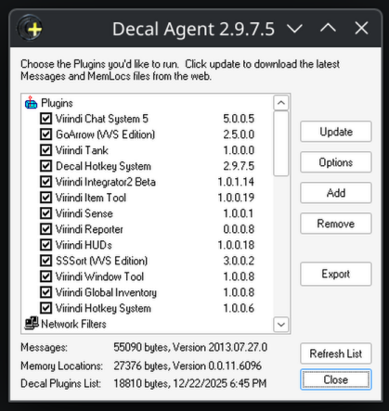

Than klik on “Browse”

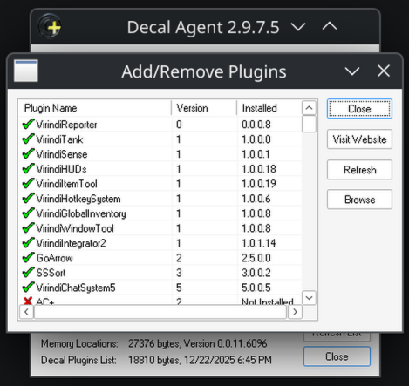

Than go to the “ThwargLauncher” Folder

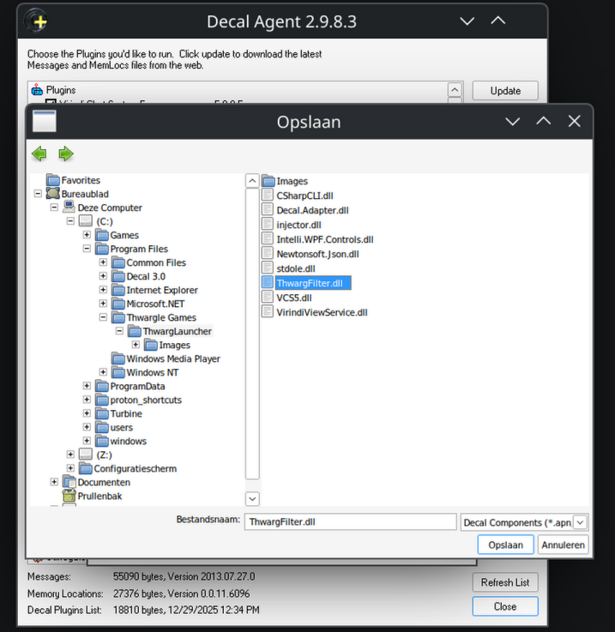

In the “Thwargle” folder select the “ThwarFilter.dll” file and klik on “Save”



Than hit “Close” (currently stil a bug in adding the filter, but besides that everything works)



And in Network Filters u wil now see “ThwargFilter”

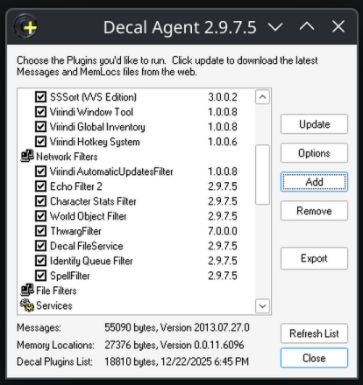

Hit Close



and exit Decal



## 4 Starting the game

In Lutris dubbelklik on “Asheron’s Call” to open the startup menu



Select Asheron’s Call and klik on “OK”

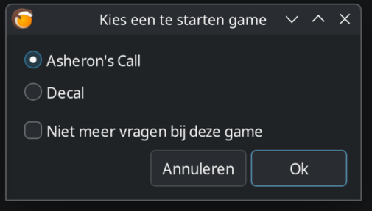

Set up Thwargle as normal bye first adding the servers u desire.

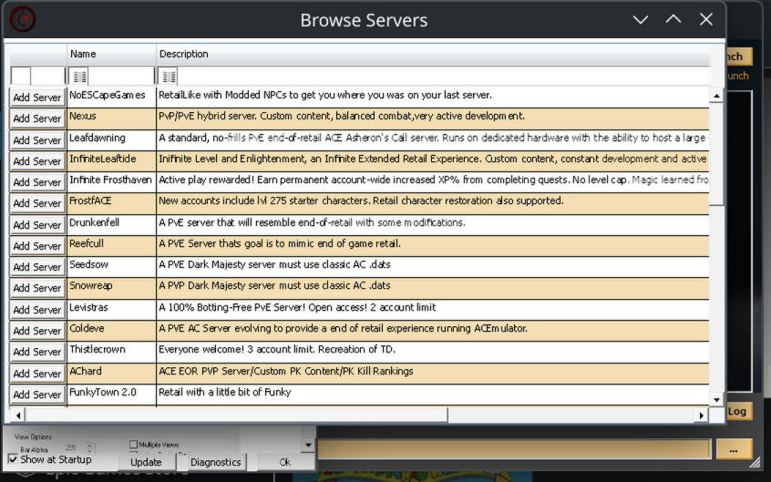

After klikking on “Add Server” the server wil be removed from the list and u can hit the X in the right corner.



I encounterd a graphic error (probertly Nvidia on linux related) where Thwarg-Launcher went completely black, just minimize Thwarg-Launcher and than just open the Launcher, this fixes the graphic bug.

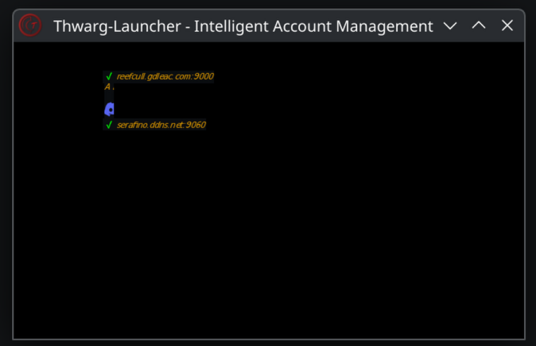

The Thwargle help file can just be closed as normal.

On Thwargle, just klik on the server u want to join

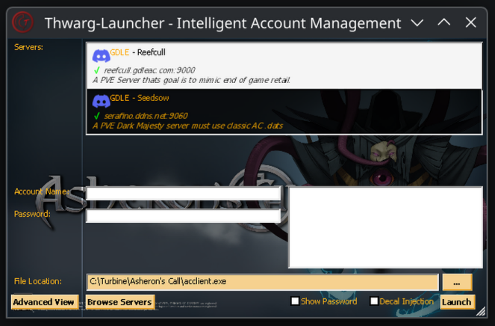

Put in the account name and password of your account



Mark “Decal Injection” to be active

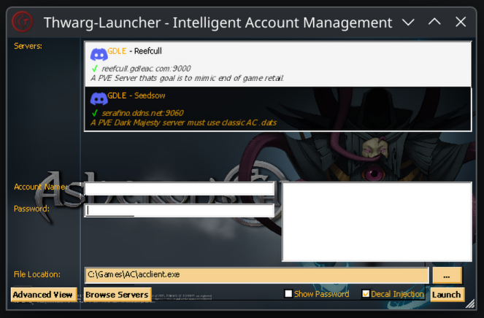

Hit “Launch” to start the game, have fun :-)